August 30th, 2008
Hi
Last Saturday evening, I watched the Olympics closing ceremony. It was not as interesting as the opening ceremony. Still, I recorded both ceremonies. When speaking to Nadine on Skype chat, she said that he US narrators of the ceremony were very poor and were unable to explain what was going on. HK was therefore luckier; I watched the TVB (English) link and they did comment on the meanings of things we were seeing. Over the years, there have been many comments of the poor quality of US narrators, not just from overseas countries, but even within the US. The most recent I chanced upon was a withering article from a commentator in Seattle about a US broadcast (not sure which is was). Many years ago, I watched a Royal ceremony in the UK (?Diana’s wedding), and the US commentator (?Tom Brokow ?Dan Rather) talked about the ‘funny hats’ that the Horse Guards wore instead of making intelligent comments about them.

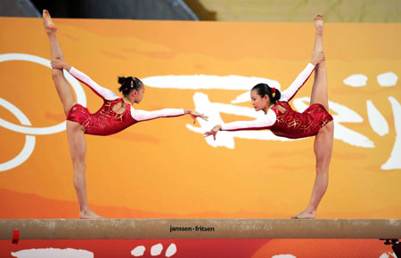
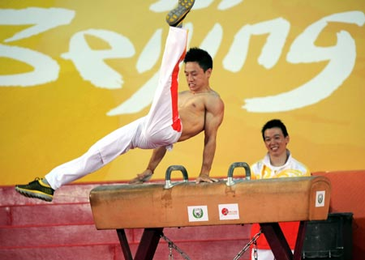
Yesterday, some of China’s medal winners were in HK to give performances at various venues. This included divers, gymnasts and table tennis players (pictures). One of the little girls in the picture is the “16-year old”. The Para-Olympics equestrian events take place in HK soon.
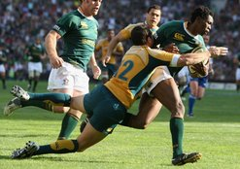
Yesterday, in a complete and unexpected reversal of form, the Springboks thrashed the Wallabies 53-8 in Johannesburg, with SA scoring 8 tries! The altitude at about 5000 ft in Jburg may have been a factor, though this would also affect the SA players who do not live on the high veld (plateau). So, SA managed to finish their six matches with two wins. NZ and Australia have three wins each so the last match in a couple of weeks will decide who the tri-nations champions will be.
Finished reading ‘Pride and Prejudice’ yesterday. I will now begin on the autobiography of Oliver North that you gave me Gavin. Although I am not much of a fan of North, the book should give a lot of interesting background of the Reagan years and the shenanigans that went on.

That’s about it for this week.
Cheers

